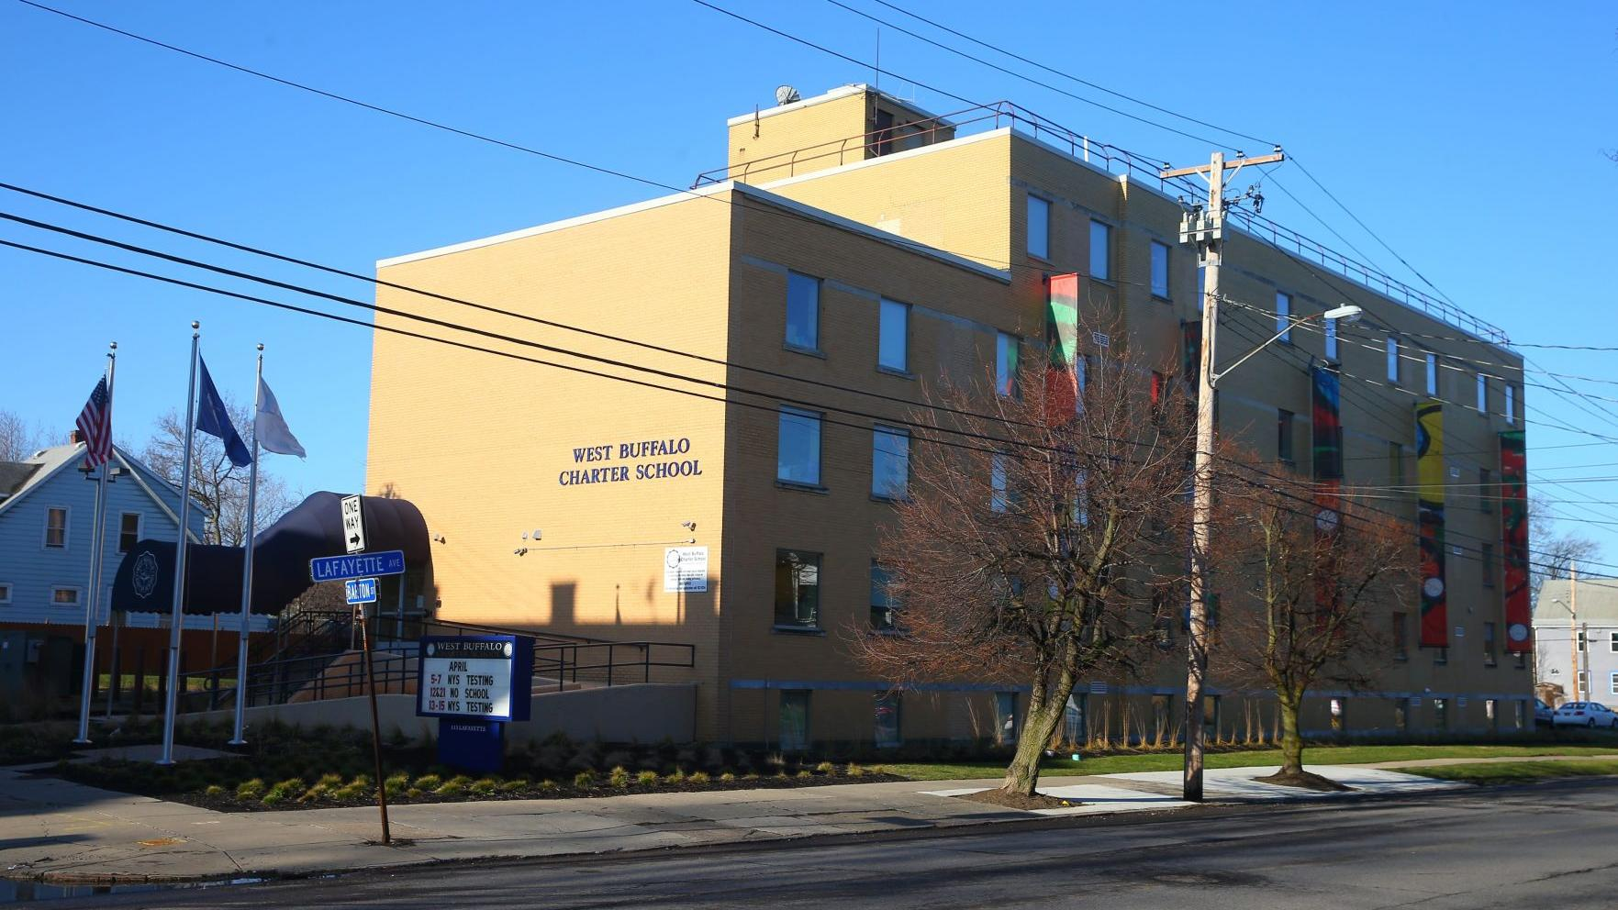

MINIMUM CAPACITY :-

The Minumum intake capacity

of students is between 150-350

children

LIBRARY :-

The Libarary is Available.

CANTEEN:-

The Canteen Facility is Available.

BOARDING :-

No availablility of boarding.

SPORTS :-

There are different categories

sports available.

Girls Volleyball

Boys Volleyball

Football

|  |  |  |  |
| --- | --- | --- | --- |
| WEST BUFFALO CHARTER SCHOOL  BUFFALO - SCHOOL | |  |  |
| **School Detail :-**  West Buffalo Charter School is determined to help each student reach his or her fullest potential. Daily instruction contains a unique blend of speech and language skills and intensive literacy instruction. West Buffalo Charter School allows students to explore their interests, establish and maintain positive relationships, and maximize their individual successes.  Tomorrow’s future leaders are sitting in our classrooms today. With small class sizes, a rigorous curriculum aligned with the NYS Next Generation Learning Standards, and high expectations, West Buffalo Charter School develops an exceptional foundation of literacy skills for all students in grades K-8. West Buffalo Charter School is a place where diversity is celebrated, individual differences are accepted, and student success is maximized.  West Buffalo Charter School is determined to help each student reach his or her fullest potential. Daily instruction contains a unique blend of speech and language skills and intensive literacy instruction. West Buffalo Charter School allows students to explore their interests, establish and maintain positive relationships, and maximize their individual successes. | |  |  |
|  |
|